Peter McHugh.
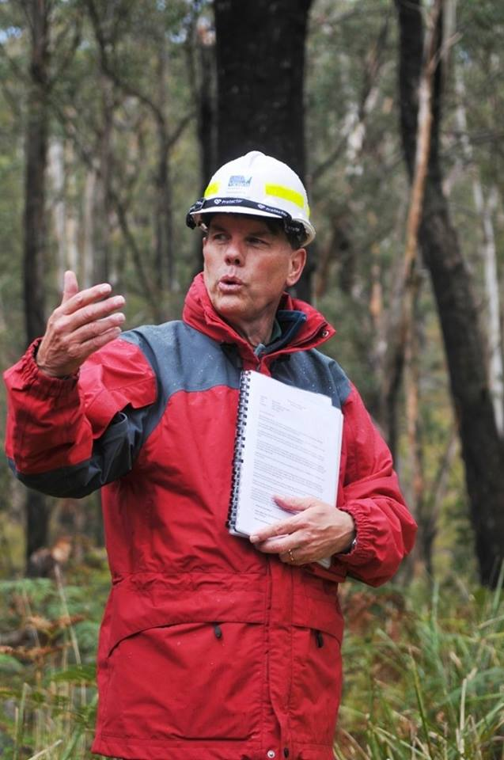

Peter McHugh graduated with a diploma from the Victorian School of Forestry at the end of 1977 and his first postings with the Forests Commission Victoria (FCV) were to Mirboo North and then later to Kallista/Gembrook.
Peter was awarded two years of full-time study leave to attend Melbourne University to complete a Bachelor of Forest Science in 1979 and 1980.
Upon graduation, Peter headed a team to examine the recovery of sawn timber from logs produced on State forests.
After another short two-year tour-of-duty with the Forest Research Branch based at Sherbrooke Peter found himself caught up in the prolonged restructure process that accompanied the formation of the Department of Conservation Forest and Lands (CFL) from mid-1983.
Surviving the turmoil, Peter finally secured a role in the newly formed Dandenong Region of CFL, first as Resource Assessment Officer where he was instrumental in the introduction of Geographic Information Systems (GIS) for the Department, then later at Woori Yallock and Powelltown as Senior Forester for the Yarra Valley preparing a major Forest Management Plan.
It was here that Peter developed a strong interest in community forestry and was later able to study in Indonesia, Canada, Sweden and the UK.
In another departmental restructure during late 1993 Peter moved to Gippsland as Senior Forester and then held a number of varied senior roles including Regional Forest Manager and State Roading Manager over the subsequent decades.
Peter rose through various firefighting roles during the 1978 Alpine fires and Ash Wednesday in 1983, from crew leader, sector boss and Air Attack Supervisor to eventually become a Level 3 Planning Officer and Incident Controller and finally the role of Agency Commander.
Like most staff, Peter was heavily committed to all the large campaign fires across Gippsland including the alpine fires in 2002/03, 2006/07, Aberfeldy/Seaton in 2013, Boolarra and Black Saturday in 2009 as well as the Hazelwood Coalmine fire in 2014.
His work in developing a unique bushfire leadership program known as the Cobaw Staff Ride, which was based on telling the story and “walking the ground” of an escaped a planned burn that occurred in the Cobaw Ranges north of Melbourne in April 2003, won him the prestigious State Fire Award in 2012.
This was the first bushfire staff ride in Australia.
Peter was subsequently invited by the US Forest Service and US Marines as a participant/instructor in their senior fire leadership course which examined the lessons learned from the Battle of Gettysburg.
Peter retired from the Department of Environment, Land, Water & Planning (DELWP) in 2016 after nearly 39 years of service and now finds time to volunteer in his local community as well as write about some of Victoria’s rich forests and bushfire history.

